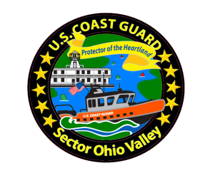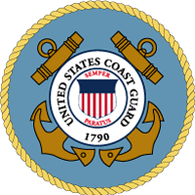**Western Rivers Orientation Course**

**Captain Amy M. Beach**

Commander, Sector Ohio Valley  
United States Coast Guard

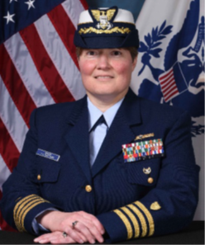Captain Beach serves as Commander, Coast Guard Sector Ohio Valley in Louisville, KY, overseeing operations for an area of responsibility that includes all or part of 10 states ranging from the eastern portion of Missouri to the southwestern corner of Pennsylvania, and from northern Alabama to Ohio. As the operational commander, she leads over 400 regular, reserve, and civilian men and women, at the Sector office, three marine safety units, two marine safety detachments, as well as six river tenders. These Sector personnel provide maritime security, search and rescue, marine safety, and environmental protection for over 3000 miles of navigable waterways on twelve major rivers that move 350 million tons of cargo annually.

Prior assignments include 9th Coast Guard District Prevention Division from June 2017-June 2019 and Commanding Officer of Coast Guard Marine Safety Unit Savannah from June 2014- June 2017. In this role, she led over 200 active duty, reserve, auxiliary and civilian men and women to carry out a variety of statutory authorities as the Captain of the Port Savannah, Officer in Charge – Marine Inspections, Federal Maritime Security Coordinator, and Federal On-Scene Coordinator in the State of Georgia.

She graduated from Dickson College in Carlisle, Pennsylvania with a Bachelor of Arts in History in 1994. She earned her commission as an Ensign in 1995 as a graduate of the Coast Guard’s Officer Candidate School. She holds a Master of Science degree in Environmental Protection and Public Safety Management from Saint Joseph’s University of Philadelphia and a Master of Science degree in National Security and Strategic Studies from the Naval War College.